|  |  |
| --- | --- |
| **Project Case** |  |
| COMP6144  Web Programming |
| **Computer Science** | **O202-COMP6144-PH03-00** |
| ***Valid on*** *Odd Semester Year 2020/2021* | **Revision 00** |

1. Seluruh kelompok tidak diperkenankan untuk:

*The whole group is not allowed to:*

* + - Melihat sebagian atau seluruh proyek kelompok lain,

*Seeing a part or the whole project from other groups*

* + - Menyadur sebagian maupun seluruh proyek dari buku,

*Adapted a part or the whole project from the book*

* + - Mendownload sebagian maupun seluruh proyek dari internet,

*Downloading a part or the whole project from the internet,*

* + - Mengerjakan soal yang tidak sesuai dengan tema yang ada di soal proyek,

*Working with another theme which is not in accordance with the existing theme in the matter of the project,*

* + - Melakukan tindakan kecurangan lainnya,

*Committing other dishonest actions,*

* + - Secara sengaja maupun tidak sengaja melakukan segala tindakan kelalaian yang menyebabkan hasil karyanya berhasil dicontek oleh orang lain / kelompok lain.

*Accidentally or intentionally conduct any failure action that cause the results of the project was copied by someone else / other groups.*

1. Jika kelompok terbukti melakukan tindakan seperti yang dijelaskan butir 1 di atas, maka **nilai kelompok** yang melakukan kecurangan (menyontek maupun dicontek) akan di – **NOL** – kan.

*If the group is proved to the actions described in point 1 above, the score of the group which committed dishonest acts (cheating or being cheated) will be “Zero”*

1. Perhatikan jadwal pengumpulan proyek, segala jenis pengumpulan proyek di luar jadwal tidak dilayani.

*Pay attention to the submission schedule for the project, all kinds of submission outside the project schedule will not be accepted*

1. Jangan lupa untuk melihat kriteria penilaian proyek yang ditempel di papan pengumuman, atau tanya asisten anda.

*Don’t forget to look at the project assessment criteria that posted on the announcement board, or ask your teaching assistant.*

1. Persentase penilaiaan untuk matakuliah ini adalah sebagai berikut:

*Marking percentage for this subject is described as follows:*

|  |  |  |
| --- | --- | --- |
| **Tugas Mandiri**  *Assignment* | **Proyek**  *Project* | **UAP**  *Final Exam* |
| - | 100% | - |

1. Software yang digunakan pada matakuliah ini adalah sebagai berikut:

*Software will be used in this subject are described as follows:*

|  |
| --- |
| **Software**  *Software* |
| PHP Composer 1.10.7  PHP Storm 2020.1.2  Visual Studio Code  Laravel Framework 7  XAMPP 7.4.7  Firefox / Chrome |

## Ekstensi file yang harus disertakan dalam pengumpulan tugas mandiri dan proyek untuk matakuliah ini adalah sebagai berikut:

*File extensions should be included in assignment and project collection for this subject are described as follows:*

|  |  |
| --- | --- |
| **Tugas Mandiri**  *Assignment* | **Proyek**  *Project* |
| - | Folder Project (PHP, SQL, Image Files (JPG / PNG), ENV, HTML, CSS, SCSS, JS, JSON, HTACCESS, ARTISAN) |

General Provisions:

* Use **MySQL** asdatabase and must using **Laravel Migration** features.
* **All file upload** feature such as image and document must be **stored to server storage**.
* Use PHP Framework **Laravel 7** to build the project.
* Use Laravel **MVC** concept (**Model, View, Controller**) to build the project.
* Use **Eloquent Query / Query Builder** to work with database.
* You are free to design your own database table **based on given requirements**.
* Print screen given below is only an example. You are free to create your own user interfaces.
* It is **prohibited** to install any kind of Laravel packages. You must use fresh installation of **Laravel 7**.
* Only **validation** in the **backend** (using Laravel) will be graded.

## Soal

*Case*

**PHizza Hut**

**PHizza Hut** is a new pizza restaurant that is already well known in the business. The manager of **PHizza** **Hut** has decided that he wants to expand his business even more. He wanted to make a website for his restaurant so their customer can order online and get their pizza delivered.

As a web developer, you are asked to create a website using **Laravel** **7** for this online shop. There are three types of user’s role in this website: **Admin**, **Member**, and **Guest.**

* + - 1. **Login**

This is the page that allows user to log in to the website. If the user enters a wrong combination of email and password, then the website will show an error message.

If user entered a correct **Email** and **Password** combination, the page would redirect user to the home page. If the customer chooses **Remember Me**, then the website will save the user’s cookies for **2 hours.**

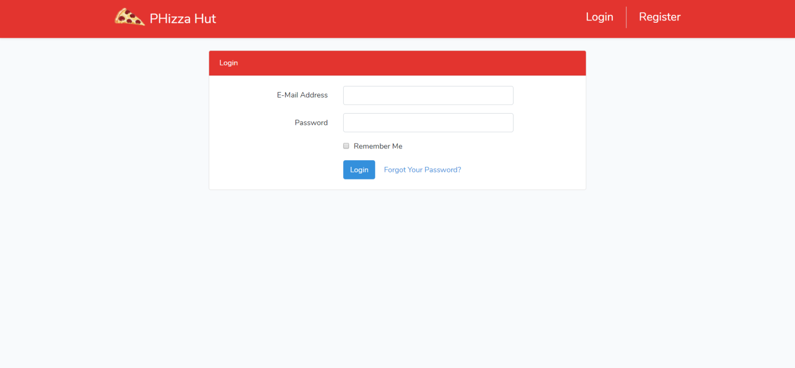

***Figure 1. Login Page***

1. **Register**

The customer can **register** themselves an account in this page. Each will be **validated** as shown below. If the customer inputted an **incorrect** **data**, then the page will show an **error** **message.** The following validation will be applied to each field:

|  |  |
| --- | --- |
| **Field** | **Information** |
| **Username** | Must be **filled** |
| **Email Address** | Must be **filled** with **email validation** and **unique** |
| **Password** | Must be **filled** and **minimum 6 characters length** |
| **Confirm Password** | Must be **filled** and **same with password** |
| **Address** | Must be **filled** |
| **Phone Number** | Must be **filled** and must be **numeric** |
| **Gender** | Must be **filled** |

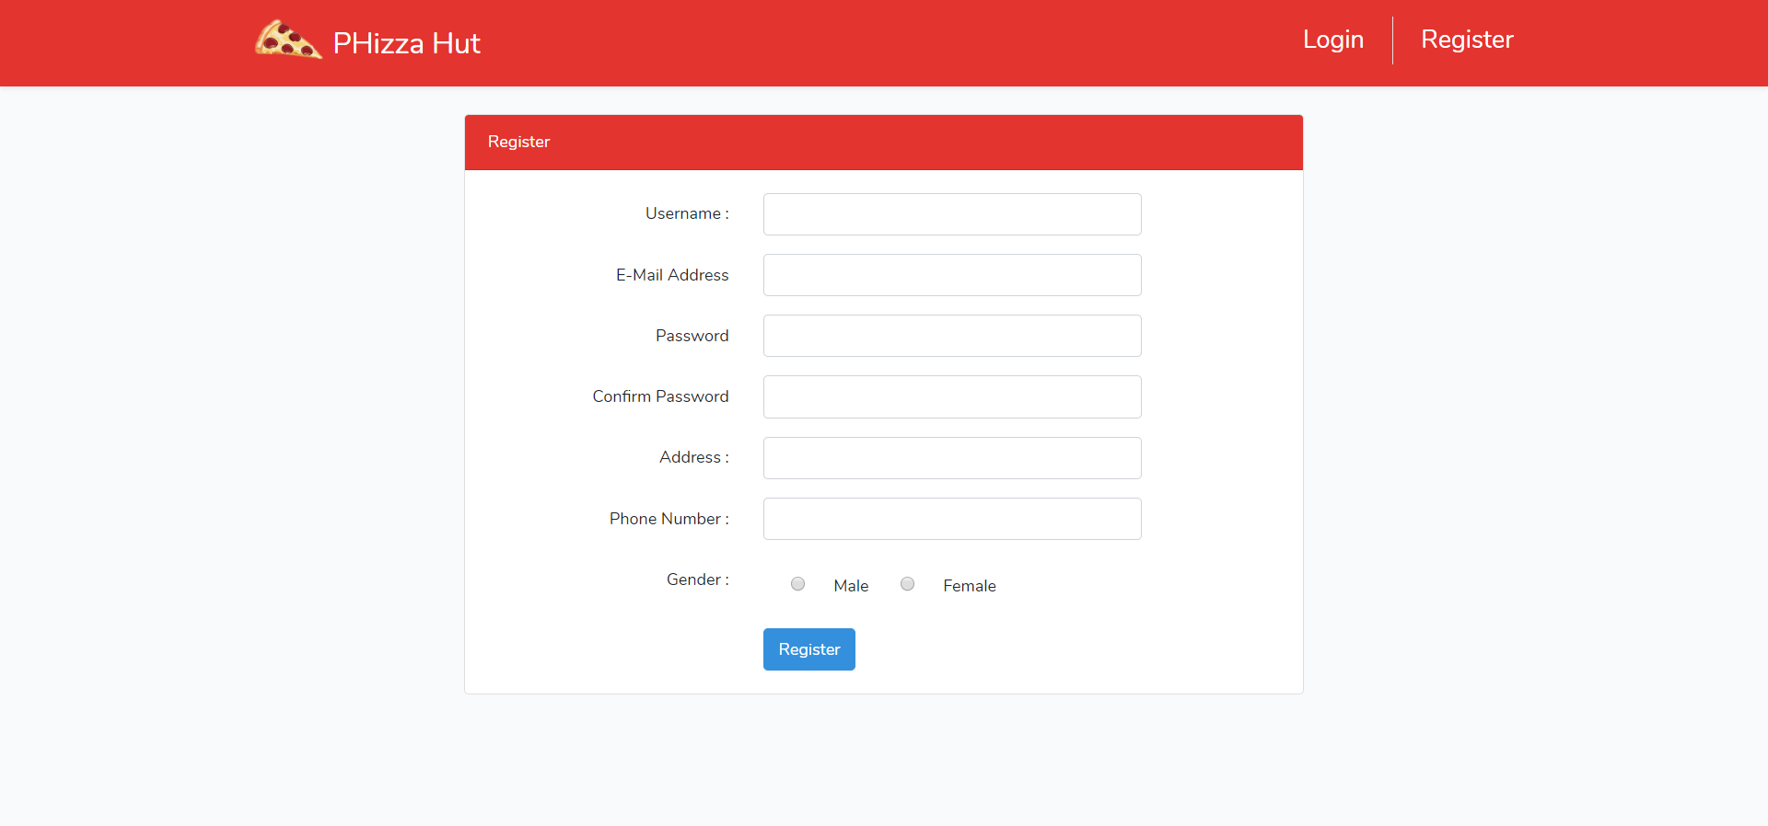

***Figure 2. Register Page***

1. **Home Page**

This page is where the user can view all the **pizza**. **All user** can access this page. In this page, Users can also **search by name of pizza** andthe page willbe **paginated** to only show **6 pizzas** each page**.**

In this page, guest can **Login** or **Register** to the page**,** this page can be accessed by **all of the users.** Logged in member will have extra button on the navigation bar, which is **view cart** and **view transaction history**. Meanwhile, admin will have extra button which is **view all user** and **view all user transaction.** Three buttons to **add**, **edit** and **delete pizza** will also appear if the logged in member is admin

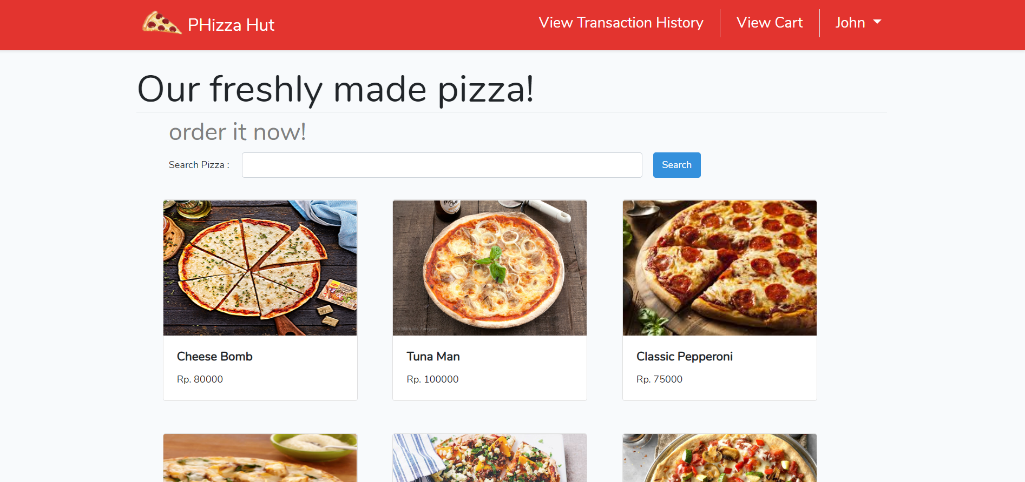

***Figure 3. Home Page (for Member)***

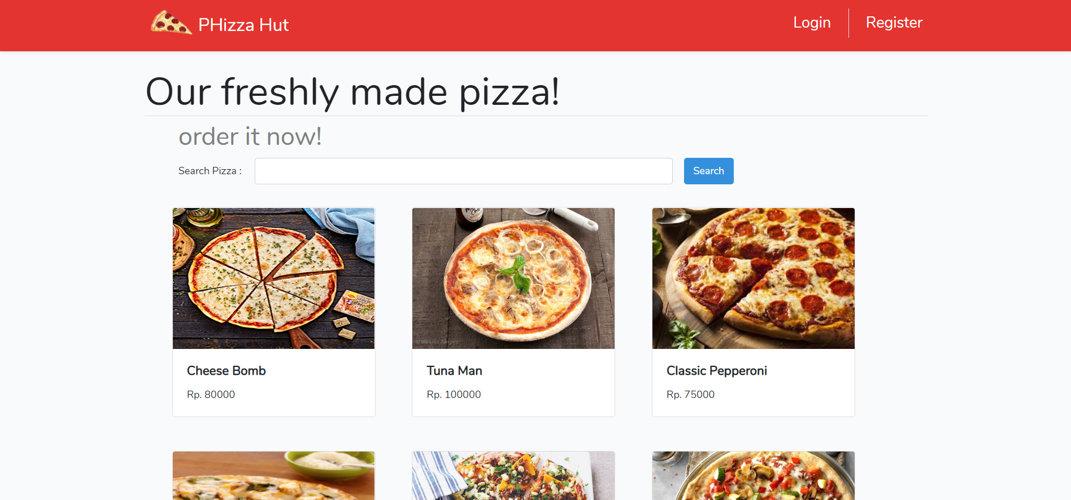

***Figure 4. Home Page (for Guest)***

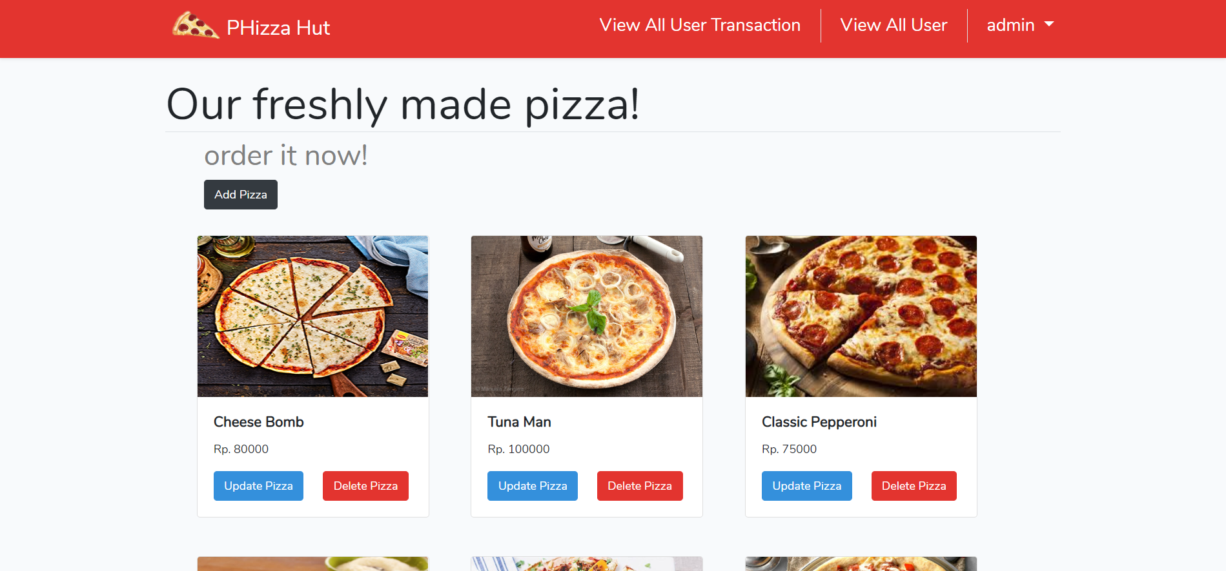

***Figure 5. Home Page (for Admin)***

1. **View Pizza’s Detail**

This page is accessible for everyone. This page shows pizza’s detail such as **Pizza Name**, **Pizza Description**, and **Pizza Price** based on the product clicked. If the user has already logged in as a member, there will be an **Add to Cart** button and a textbox to input the **quantity** of pizza that they want to buy. **Validate** the member’s input to be **at least** **1**. Make sure that **admin** **cannot** add pizza to their cart

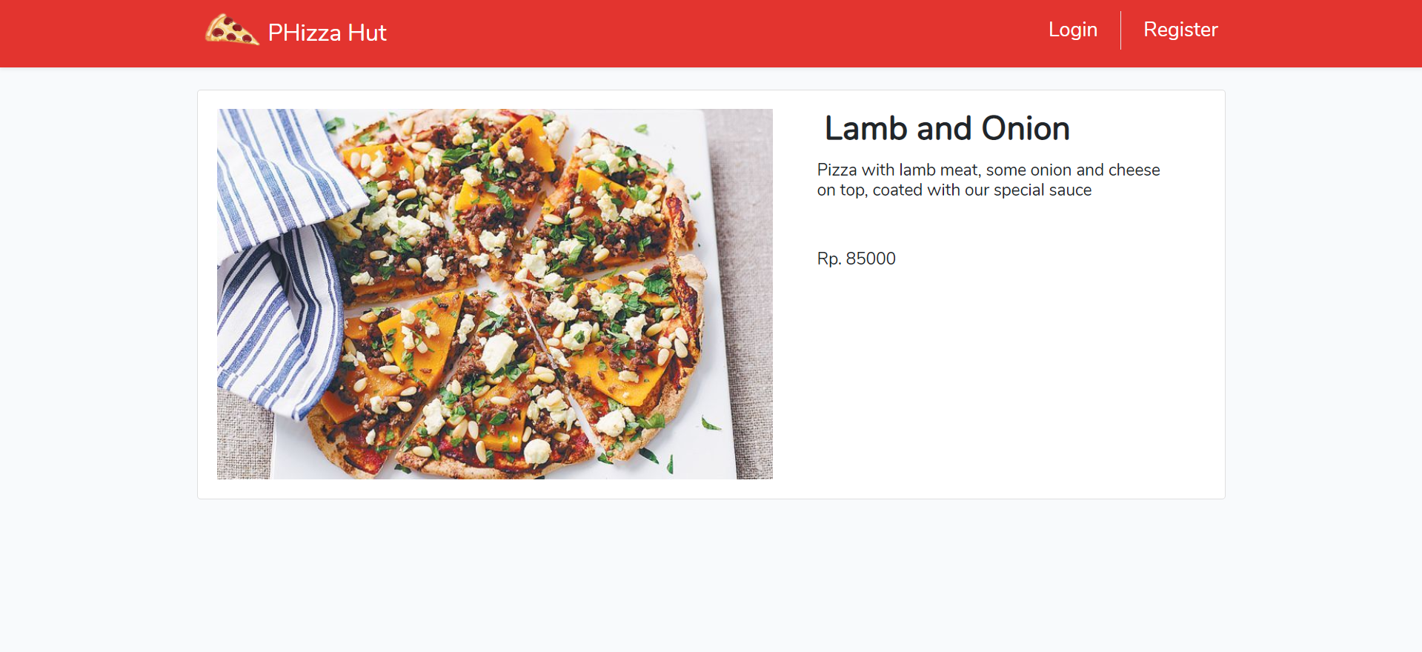

***Figure 6. Pizza’s Detail Page (for Guest and admin)***

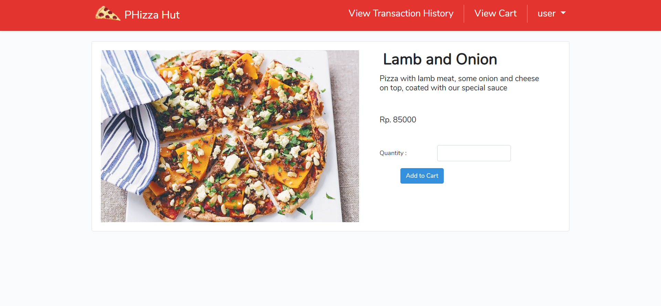

***Figure 7. Pizza’s Detail Page (for Member)***

1. **View Cart Page**

This page is only accessible for member. This page will show all product that have been added to their cart, the web will display **Pizza** **Image**, **Pizza Name**, **Pizza price**, and **quantity.** An **edit button** and a textbox will also be displayedand if clicked, the **quantity** of the cart will be **updated**. A **delete button** will also be displayed and if clicked, the product will be **removed**. In this page, member can also **Check out** the cart, **validate** that the Checkout button will be shown only when their **cart is not empty**. If the member clicked on the **checkout** button, their cart will be cleared, and a new **transaction** will be added.

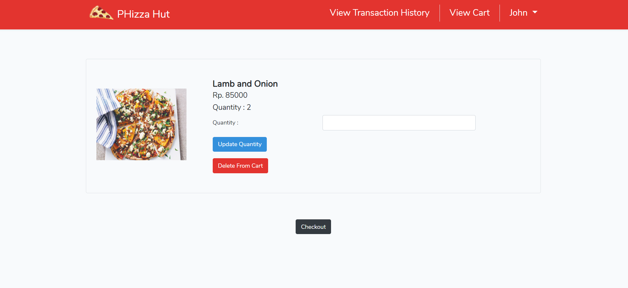

***Figure 8. View Cart Page***

1. **Transaction History Page**

Transaction history page can be accessed by clicking **view transaction history** button in the **navigation** **bar** and can only be accessed by **member**. This page will display all the **transaction history**. The page will display the **time of the transaction**

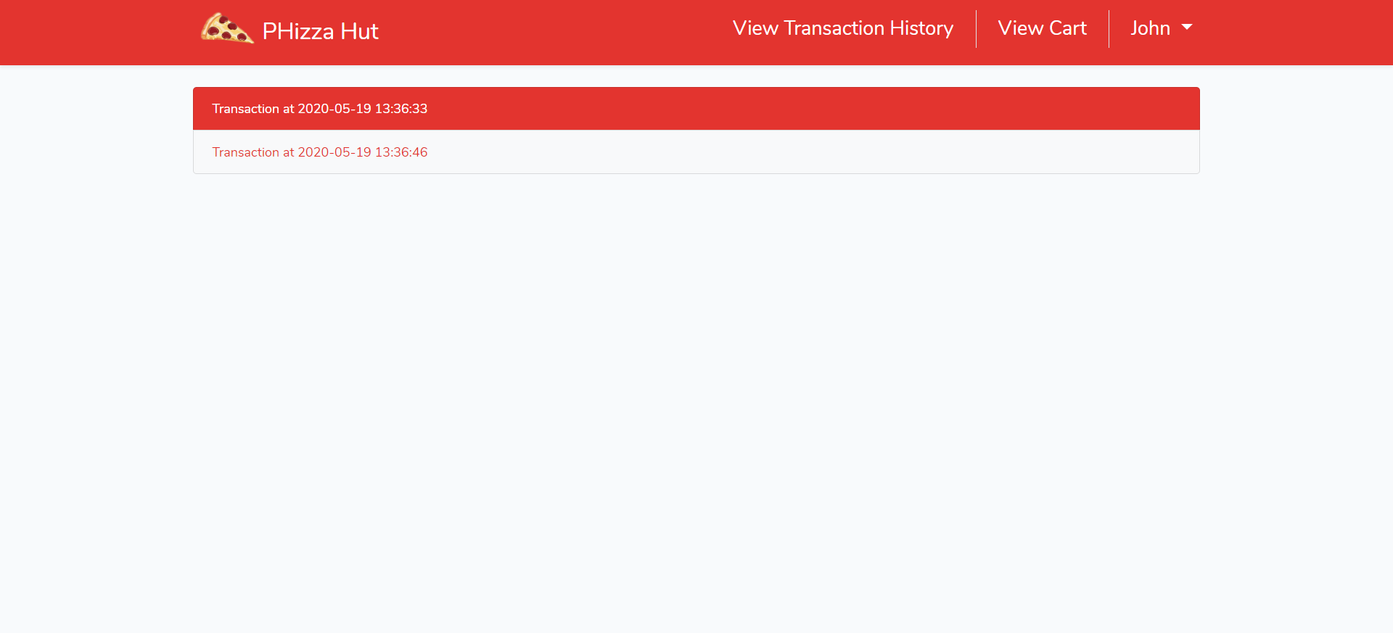

***Figure 9. Transaction History Page***

1. **Transaction Detail Page**

This page can be accessed by clicking on **one for the transaction** in transaction history page. After clicking on one of the histories, the web will show the detail of the transaction such as **Pizza Image**, **Pizza Name**, **Pizza Price**, **Quantity** and **Total Price**

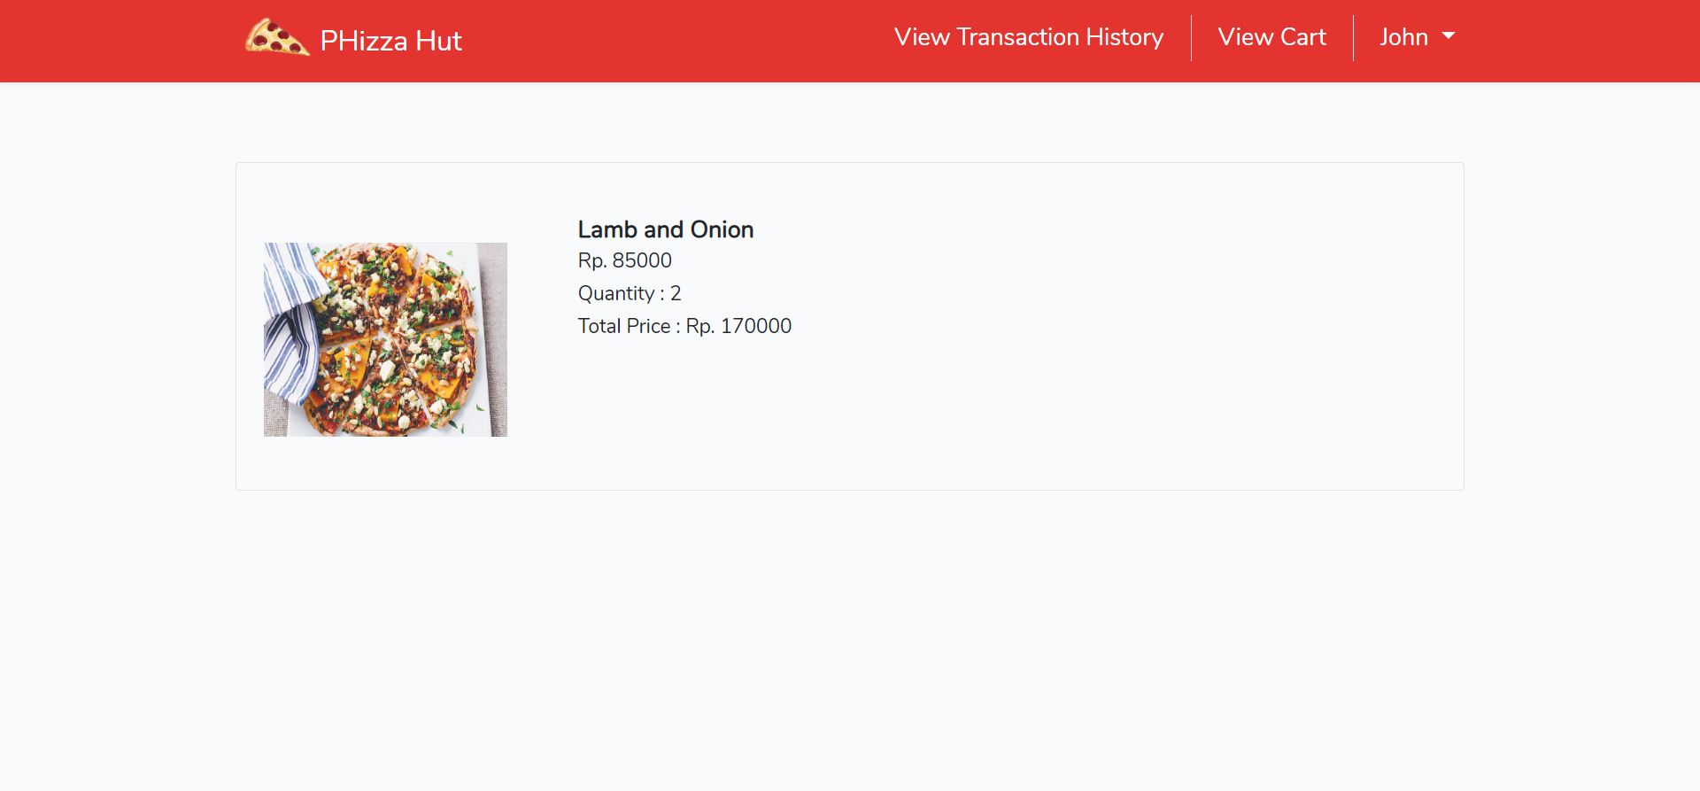

***Figure 10. Transaction Detail Page***

1. **Add Pizza**

This page can only be accessed by an Admin. In this page admin can **add a new pizza.** To add a new pizza, the admin must click the **Add Pizza Button** in the homepage. Admin must input **Pizza Name**, **Pizza Price**, **Pizza** **Description,** and **Pizza** **Image** to add a new pizza. The following validation will be applied to each field:

|  |  |
| --- | --- |
| **Field** | **Information** |
| **Name** | Must be **filled, 20 characters maximal** |
| **Description** | Must be **filled, 20 characters minimal** |
| **Price** | Must be **filled** and **minimal** **10000** |
| **Image** | Must be **filled,** must be **image** |

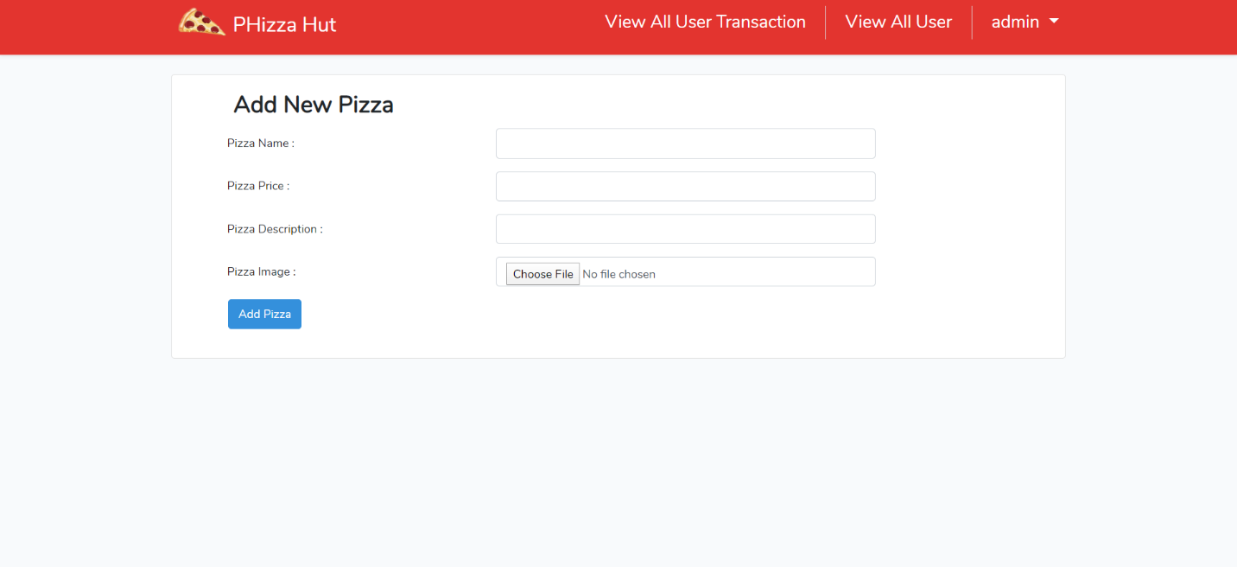

***Figure 11. Add Pizza Page***

1. **Edit Pizza**

This page can only be accessed by an Admin. In this page admin can **edit an existing pizza.** To edit a pizza, the admin must click the **Edit Pizza Button** in the homepage. Admin can change **Pizza Name**, **Pizza Price**, **Pizza Description,** or **Pizza Image**. The same validation for adding a new pizza will also be applied when editing a new pizza.

|  |  |
| --- | --- |
| **Field** | **Information** |
| **Name** | Must be **filled, 20 characters maximal** |
| **Description** | Must be **filled, 20 characters minimal** |
| **Price** | Must be **filled** and **minimal** **10000** |
| **Image** | Must be **filled,** must be **image** |

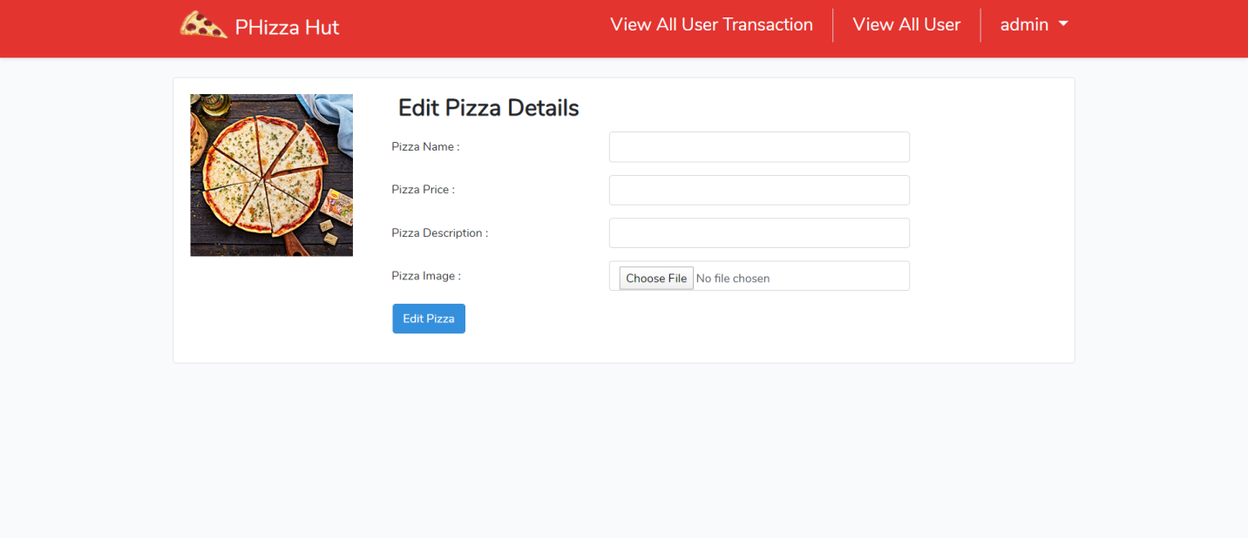

***Figure 12. Edit Pizza Page***

1. **Delete Pizza**

This page is only accessible for Admin. In this page, admin can **delete** **a pizza**. This page can be accessed when the admin pressed **Delete Pizza Button** in the homepage. After the admin pressed the delete pizza button then the pizza will be deleted.

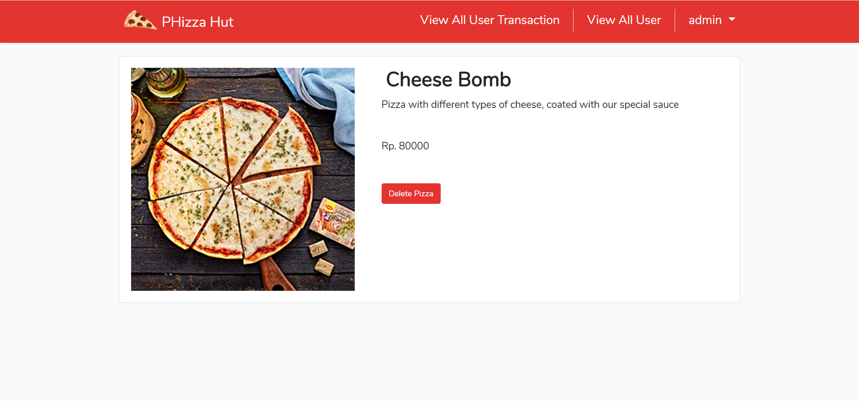

***Figure 13. Delete Pizza Page***

1. **View All User**

This page can be accessed by admin by clicking on **view all user** button. Then all of the user data such as **User ID**, **Username**, **Email**, **Address**, **Phone** **Number**, **and Gender** will be displayed.

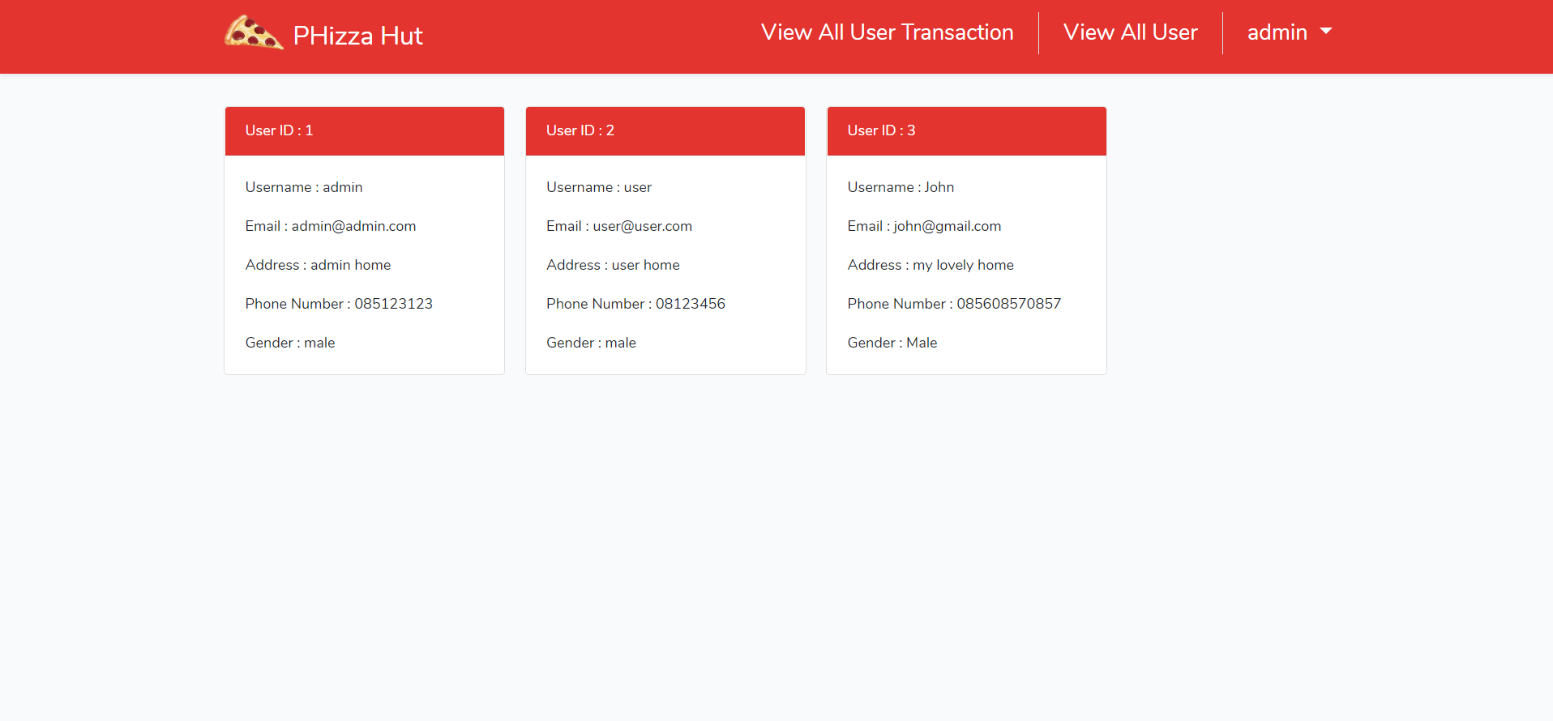

***Figure 14. View All User Page***

1. **View All User Transaction**

In this page, **admin** can see **all the transaction** that the users have made in the website. The admin can access this page by clicking on the **View All User Transaction** on the **navigation bar.** Each transaction must display **transaction date**, **user ID**, and **username.** If the admin clicked on one of the transactions, then the web will display the **details of the transaction.**

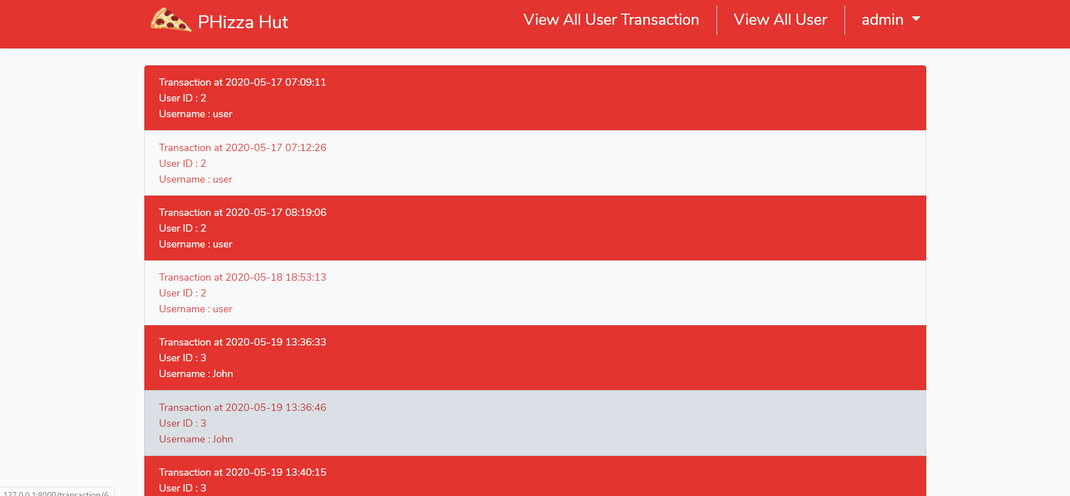

***Figure 15. View All User Transaction Page***

Here are the rules that you must follow to create your project:

1. Use appropriate software for this subject based on **Sistem Praktikum** that can be downloaded from Binusmaya.
2. Collect appropriate files for this subject based on **Sistem Praktikum** that can be downloaded from Binusmaya.
3. Include the other files that can support your project, such as:
   * All files in your project
   * Other files (image, audio, video, etc.) used in your project
   * *.DOC file (documentation of your project) that contains all pages in your project, reference links of additional files (image, audio, video, etc.) used in your project, the description about how to use your application, etc
4. If there are some hidden creativities, please note them in the existing documentation because they can greatly affect your project score

**References Link:**

<https://pngtree.com/freepng/pizza-vector-decoration_1854566.html>

<https://www.landolakes.com/recipe/16880/bacon-and-egg-breakfast-pizza/>

<https://www.beefitswhatsfordinner.com/recipes/recipe/125/beef-pepper-and-onion-pizza>

<https://www.delish.com/cooking/recipe-ideas/a26553728/best-buffalo-chicken-pizza-recipe/>

<https://www.cookinglight.com/recipes/turkey-burger-pizza>

<https://italianexpressonline.com/product/cheese-pizza-2/>

<https://www.landolakes.com/recipe/18440/garlic-chicken-pizza/>

<https://www.bowlofdelicious.com/hawaiian-pizza/>

<https://www.taste.com.au/recipes/middle-eastern-spiced-lamb-pizza/9951e140-1c5e-4017-8abf-46046cb4dbff>

<https://www.rosinarecipes.com/recipes/meatball/italian-meatball-pizza>

<https://www.foodnetwork.com/recipes/food-network-kitchen/gluten-free-mushroom-and-ricotta-pizza-3644590>

<https://www.moulinex-me.com/en/recipe/Homemade-pepperoni-pizza-/r/124141>

<https://www.southernliving.com/recipes/supreme-pizza>

<https://www.manusmenu.com/tuna-and-onion-pizza>

<https://www.tasteofhome.com/recipes/whole-wheat-veggie-pizza/>